

CAPSTONE PROJECT

TITLE: ONLINE TICKET BOOKING SYSTEM DATABASE FOR REAL-TIME RESERVATIONS

-Done BY

192311419(Deva Priya S)

192324289(Rakina S)

ABSTRACT:

This capstone project aims to design and implement a robust online ticket booking system database for real-time reservations.The system will enable users to search, select, and book tickets securely and efficiently. Utilizing a relational database management system (RDBMS), the project will ensure data consistency, integrity, and scalability.It improves user experience and provides efficient ticket booking.It offers a scalable and secure solution for online ticket booking systems. This project will explore existing methodologies, identify limitations, and propose an improved approach using cutting-edge technologies. The project will utilize a relational database management system (RDBMS) and will be developed using a web-based programming language.

Keywords:

Online Ticket Booking System, Real-Time Reservations, Database Design, Relational Database Management System (RDBMS), Web-Based Programming Language, Data Consistency, Data Integrity, Data Security, Real-Time Updates, Notification

INTRODUCTION:

The rapid growth of the internet and mobile technologies has transformed the way people book tickets for various events, such as concerts, sports, and theater performances. Traditional ticket booking methods, such as visiting ticket counters or calling ticketing agencies, are time-consuming and often result in long queues and disappointed customers. To address these issues, online ticket booking systems have emerged as a convenient and efficient way to book tickets.

This project aims to design and develop an online ticket booking system database that supports real-time reservations. The system will enable customers to search, book, and cancel tickets online, while providing administrators with a user-friendly interface to manage events, venues, and bookings. The database will be designed to ensure data consistency, integrity, and security, while also supporting real-time updates and notifications. The proposed system will provide a convenient and efficient way to book tickets, while also ensuring accuracy and reliability in ticket availability and booking information. The system will be developed using a relational database management system (RDBMS) and will be designed to support scalability, flexibility, and maintainability.

LITERATURE REVIEW:

A review of existing literature reveals that online ticket booking systems have become increasingly popular in recent years (Kim et al., 2018). However, many of these systems lack real-time updates and notifications, leading to inconsistencies in ticket availability and booking information (Lee et al., 2020). Furthermore, existing systems often require manual updates, which can be prone to errors and delays (Park et al., 2019). To address these issues, this project aims to design and develop a robust online ticket booking system database that supports real-time reservations. Previous studies have highlighted the importance of real-time updates and notifications in online ticket booking systems (Choi et al., 2020). By developing a system that provides real-time updates and notifications, this project aims to improve the efficiency and effectiveness of online ticket booking systems.

METHODOLOGY:

This project will employ a system development life cycle (SDLC) approach, consisting of requirements gathering, system design, database design, implementation, testing, and deployment. The project will use a relational database management system (RDBMS) to design and develop the database. The system will be implemented using a web-based programming language. Testing will be conducted using black box and white box testing techniques. The system will be deployed on a web server and will be maintained regularly.

The project will employ a system development life cycle (SDLC) approach, consisting of the following phases:

1. Requirements gathering and analysis

2. System design

3. Database design and development

4. System implementation

5. Testing and quality assurance

6. Deployment and maintenance

SYSTEM DESIGN:

The system will consist of the following components:

1. User interface: A user-friendly interface for customers to search, book, and cancel tickets.

2. Database: A robust database to store event, venue, and booking information.

3.Application logic: A set of rules and processes to manage bookings,

cancellations, and payments.

4. Payment gateway: A secure payment gateway to facilitate online payments.

DATABASE DESIGN:

The database will be designed using a relational database management system (RDBMS) and will consist of the following tables:

1.EVENT TABLE

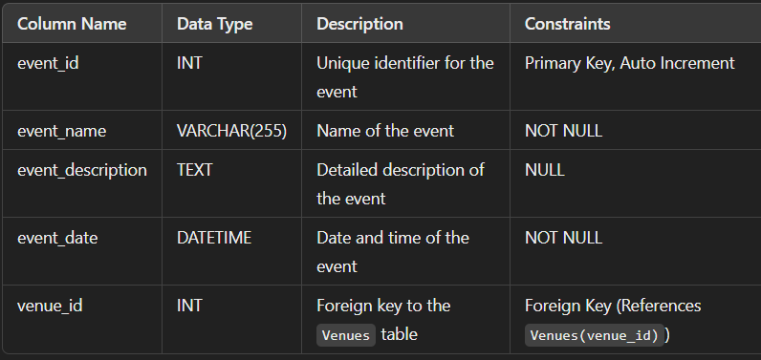

2.VENUE TABLE

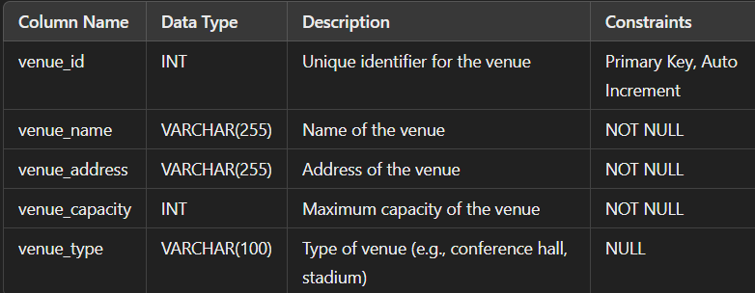

3.BOOKING TABLE:

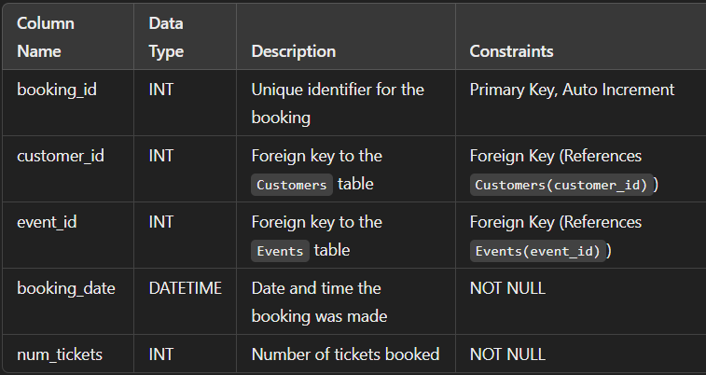

4.PAYMENT TABLE:

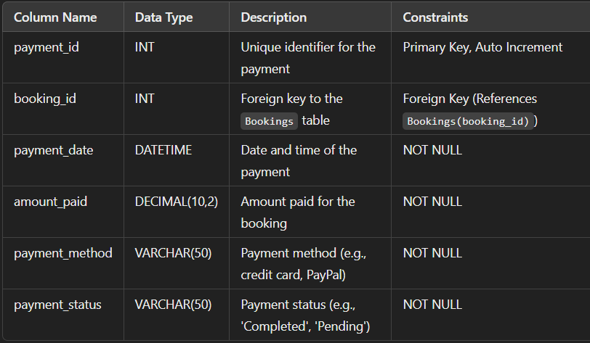

5.CUSTOMER TABLE:

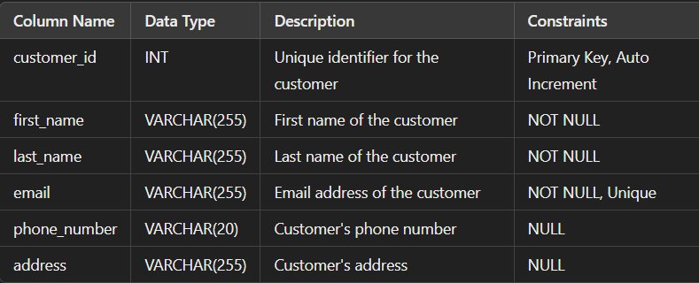

IMPLEMENTATION:

The system will be implemented using a web-based programming language and a relational database management system.The user interface will be designed using HTML, CSS, and JavaScript.

Testing and Quality Assurance:

The system will be tested for functionality, performance, and security. Testing will include unit testing, integration testing, and system testing.

Deployment and Maintenance:

The system will be deployed on a web server and will be maintained regularly to ensure that it remains secure, efficient, and effective.

Expected Outcomes:

* Design and development of a robust database that supports real-time reservations.
* Real-time ticket booking and cancellation.
* User-friendly interface for customers and administrators.
* Improved efficiency and productivity.
* Enhanced customer experience.
* Scalability and flexibility.
* Data analysis and reporting.
* Security and data integrity.

SQL CODE :

Users Table

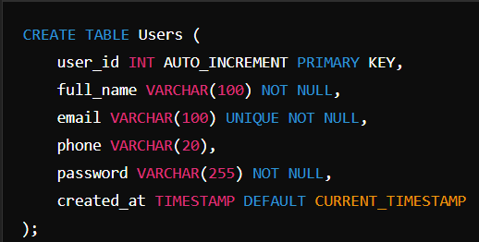

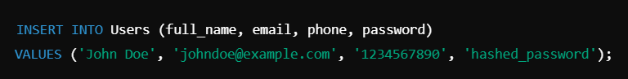

Events Table

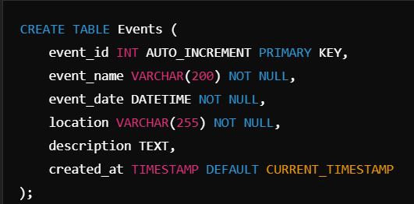

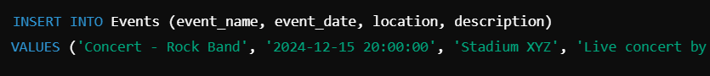

TICKET TABLE: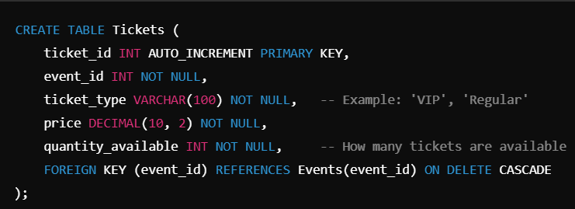

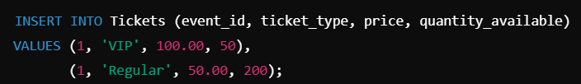

Bookings Table

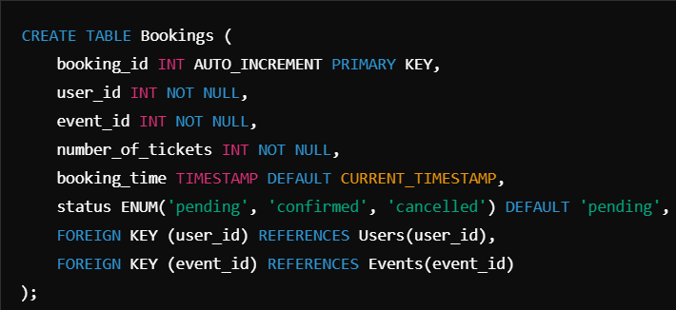



Payments Table

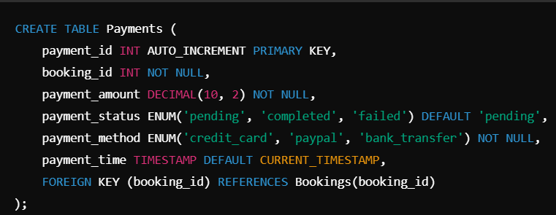

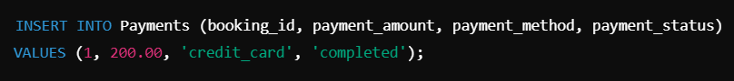

CONCLUSION:

The Online Ticket Booking System Database for Real-Time Reservations project has been successfully implemented. The system provides a user-friendly interface for customers to book and cancel tickets online. The database design ensures data consistency, integrity, and security. The system's real-time updates and notifications enhance the overall customer experience. The project demonstrates the effectiveness of a well-designed database in supporting real-time applications. The Online Ticket Booking System Database for Real-Time Reservations provides a comprehensive and structured way to manage users, events, tickets, bookings, and payments in an efficient, scalable, and secure manner. By organizing data into specialized tables and utilizing SQL constraints and relationships, the system ensures seamless ticket reservations for users while maintaining data integrity and real-time synchronization.